Getting Started with the Champ Portal

See Your Cases & Vote on Ideas
Champ Software is launching a new Customer Portal. The portal will allow you to see cases you submit and the status of those cases. The portal also lets you submit ideas for enhancements or new features to our Ideas page. This replaces the previous Ideas page on the web site, accessible to you through Nightingale Notes Help.
The new Ideas page gives you 10 votes per user to cast toward ideas you’d like to see implemented. Champ will use the ideas and votes to identify the features that are being asked for most frequently. The ideas you submitted using the old Ideas page through Nightingale Notes or by sending them to Support for the wish-list have been unduplicated and imported into the new Ideas area.
Gold Package Agencies
If you have the Nightingale Notes Gold package, you will be given an opportunity to review and vote on the top 10 most popular Ideas submitted by all users. Your agency will be contacted in October or November with details on reviewing the most popular ideas. The top 10 ideas will be estimated by our development team. The Gold task force, comprised of one representative from each Gold agency, will be presented with the ideas, the hourly development estimates, and the total amount of development hours Champ can allocate to feature requests. The ideas brought to the Gold task force for consideration will be labeled with “Brought to Gold Task Force – Under Consideration” in the Ideas portal.
The Gold Task Force will vote on which of the features are allocated hours. Once features are chosen, Champ will provide a timeline for release of the features and they will be marked as “Planned” in the Ideas portal. If you’ve voted for an Idea that is escalated to “planned” your votes for that idea will automatically be returned to you to cast for other ideas. Once an idea is implemented it will no longer be an idea that can be voted on and is marked “in production.” More on how to vote, resetting votes, etc under the Using the Ideas Page section.
Let’s look at both the Support and Ideas pages. Both are accessed through the same portal so we’ll start there.

Using the Customer Portal for the first time:
- Go to https://champsoftware.na2.teamsupport.com
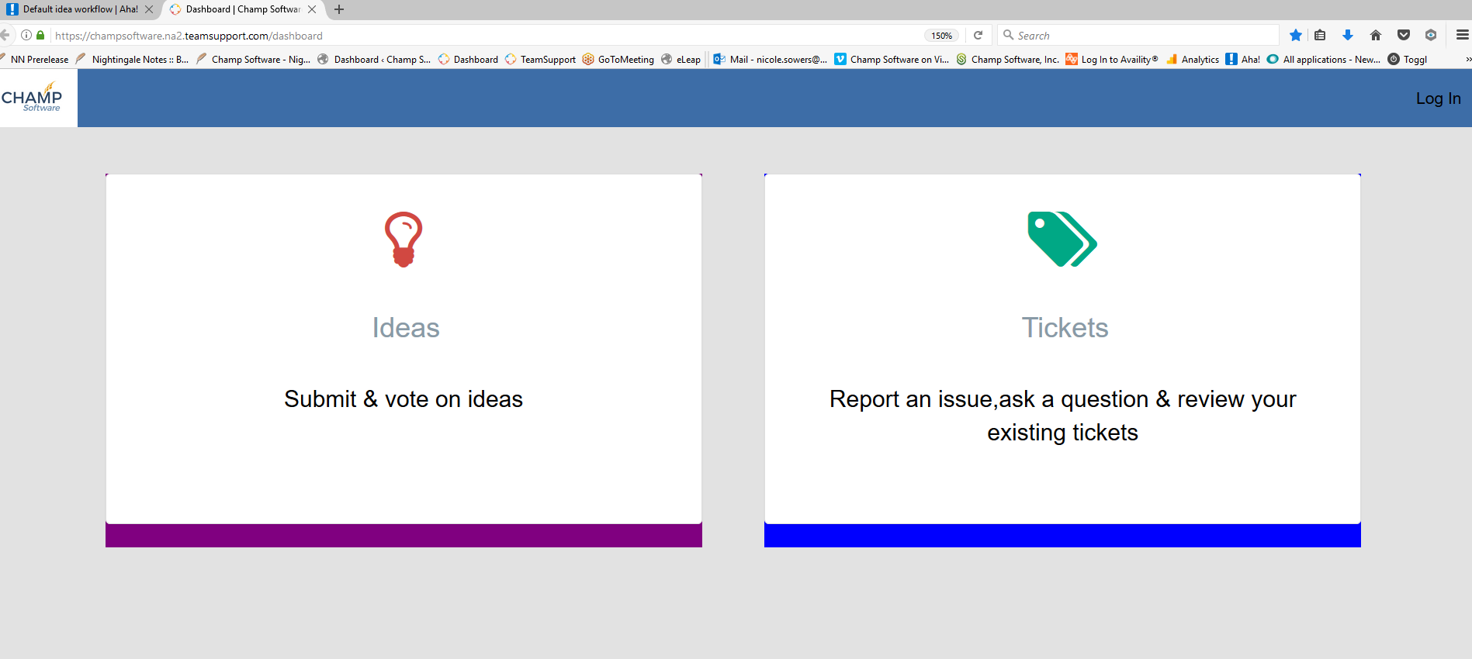

- Click Log In at the top right of the screen. 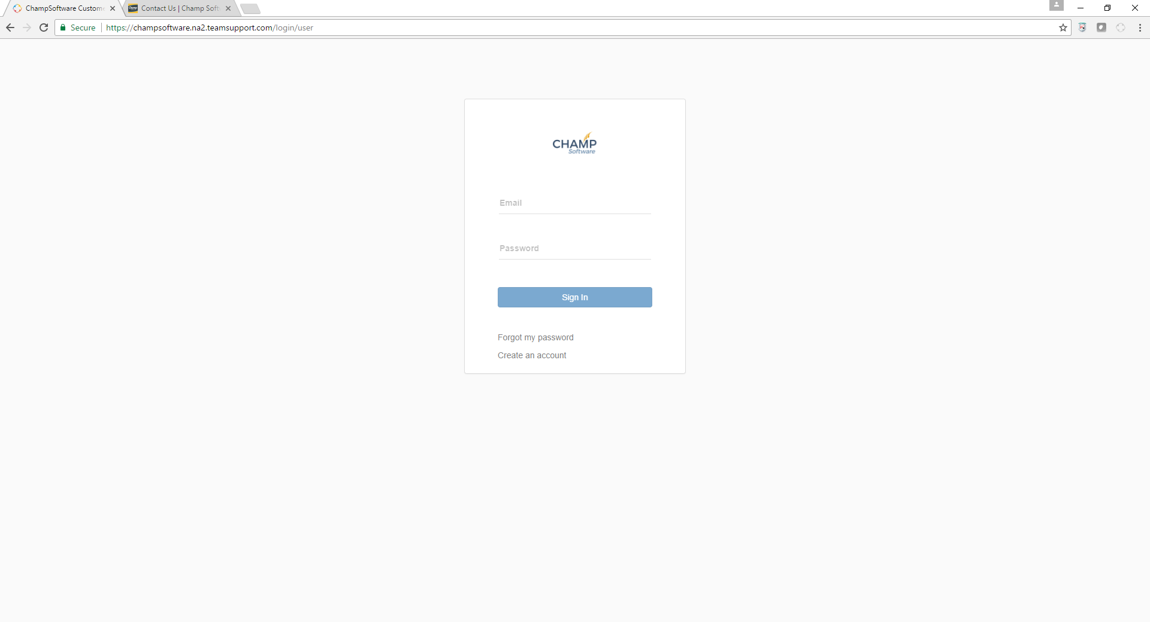
- Click on Create an account.
- Complete the 3 fields to create a new account and click the Register Me button.
- You will see the screen refresh and the login page shown above will display once again.
- Use your email and password that you just created to login. This is duplicate entry of the login information but it’s necessary to authenticate you.
- You will see the new Champ Software Customer Portal:
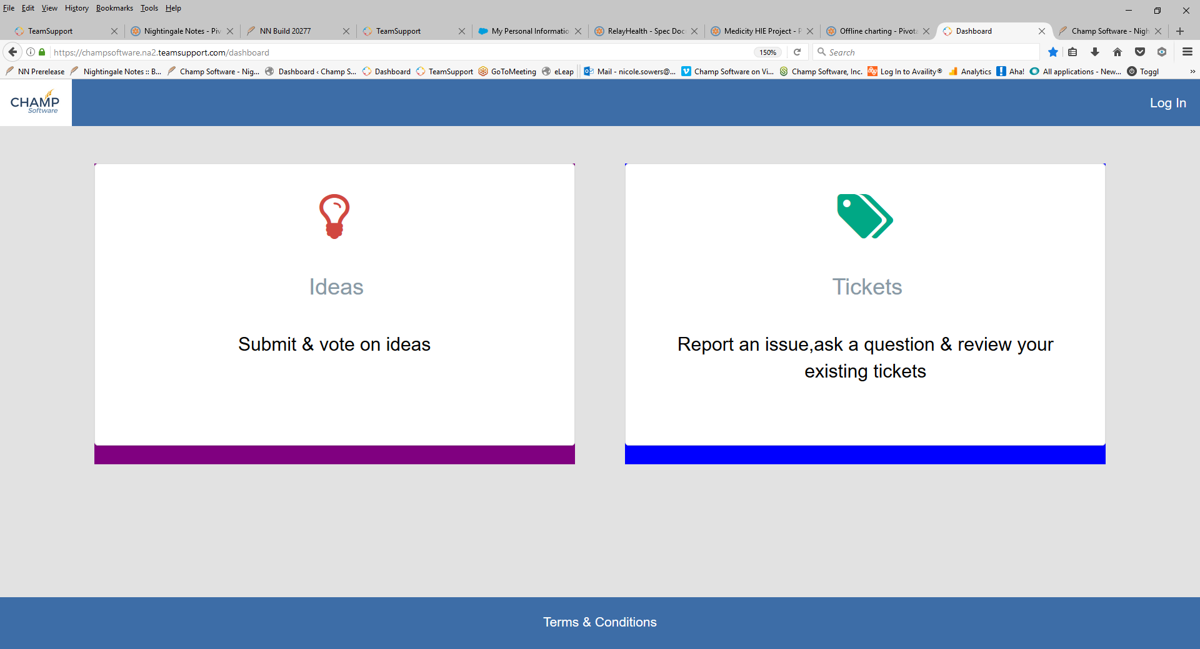

Using the Ideas Page:
- The first time you click the Ideas button you will need to create an account. You can use the same credentials for the Ideas Page as you did for the Support Portal above to keep things simple. Go to https://champsoftware.ideas.aha.io/ideas
- Click Log In/Sign up and enter your email.
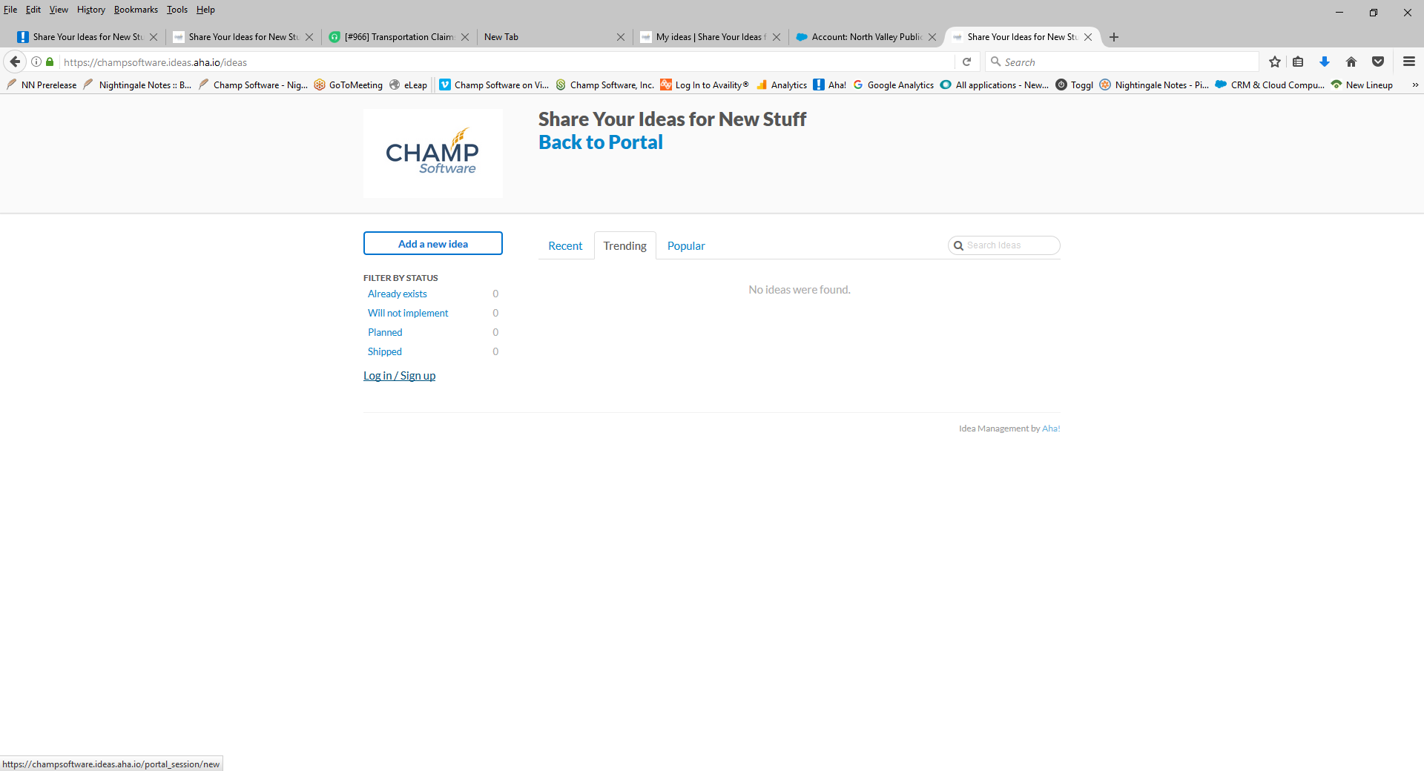
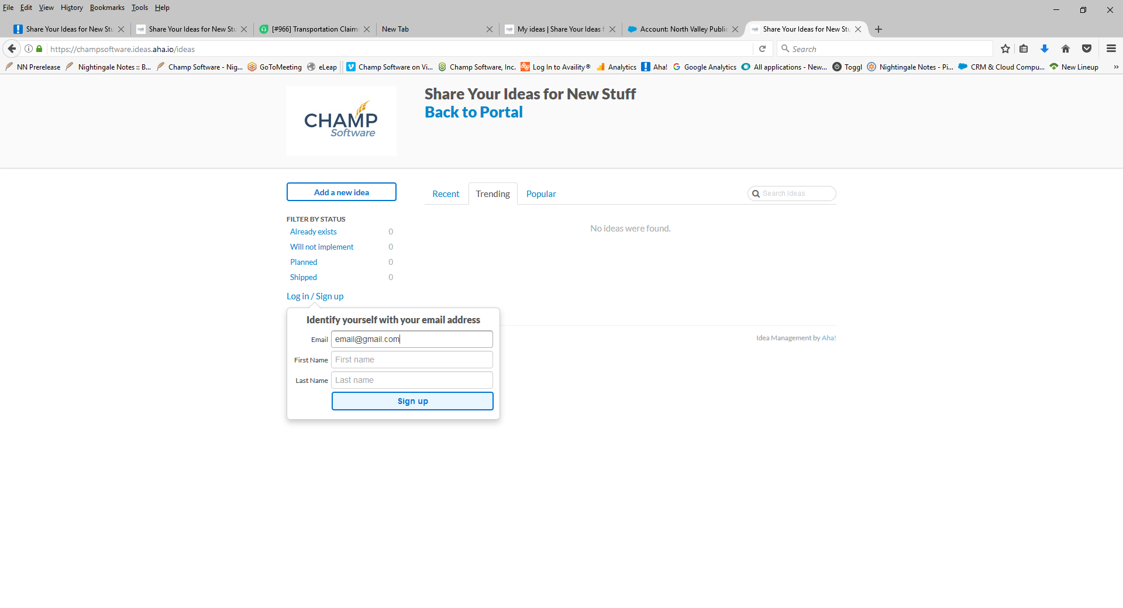
- Enter the fields and click Sign up as shown above. You will then be asked to enter your email a second time to identify and verify yourself and click Next, as shown below.
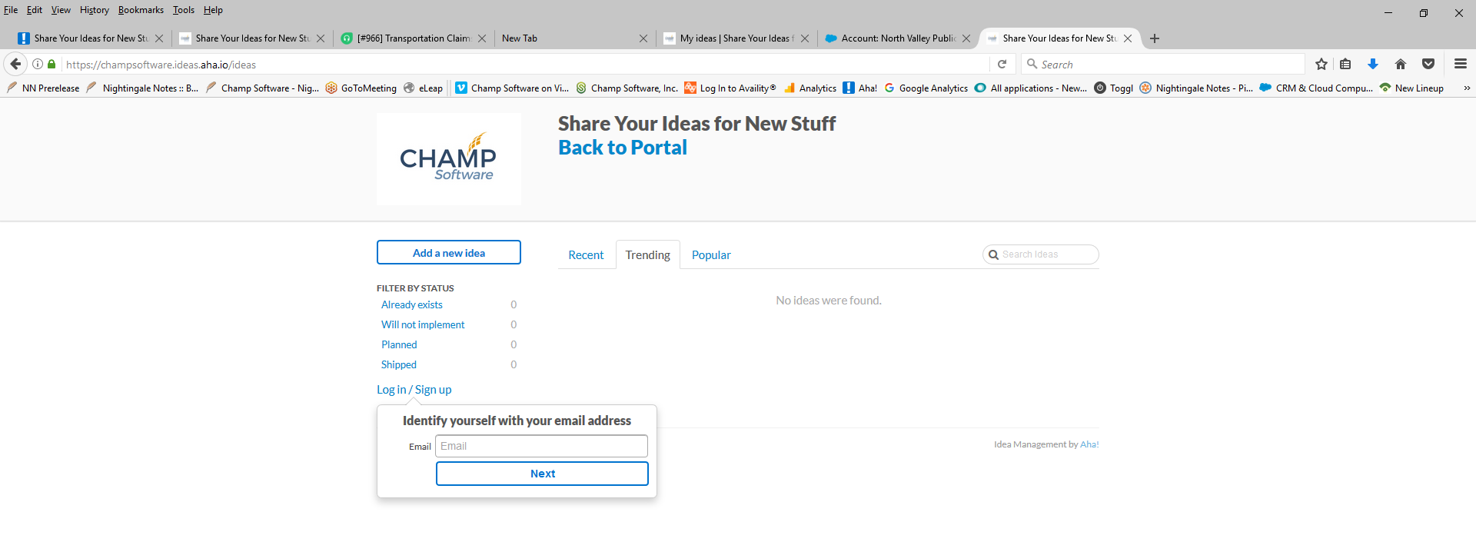
You are now successfully signed up for access to the portal to submit and track your support tickets and to the Ideas page to share and vote on ideas. All the ideas previously submitted to the Champ Ideas page, not implemented, are available to view and vote on in the new Ideas portal. We were not able to copy the information on which agencies submitted and voted on the ideas using the old site. We did bring over the total number of votes from the old system. You’ll know when an idea was imported from the old system because the submitter will show as Ideas@champsoftware.com.

Using the Ideas Page
Champ will still make mandatory governmental updates, fix issues that arise, and do other business-driven development outside of the ideas that are voted on. We have always built features around ideas from you. That’s not new. What is new is that this voting system allows us more efficient and accurate ways to measure popularity of ideas (wish list) and their importance to you.
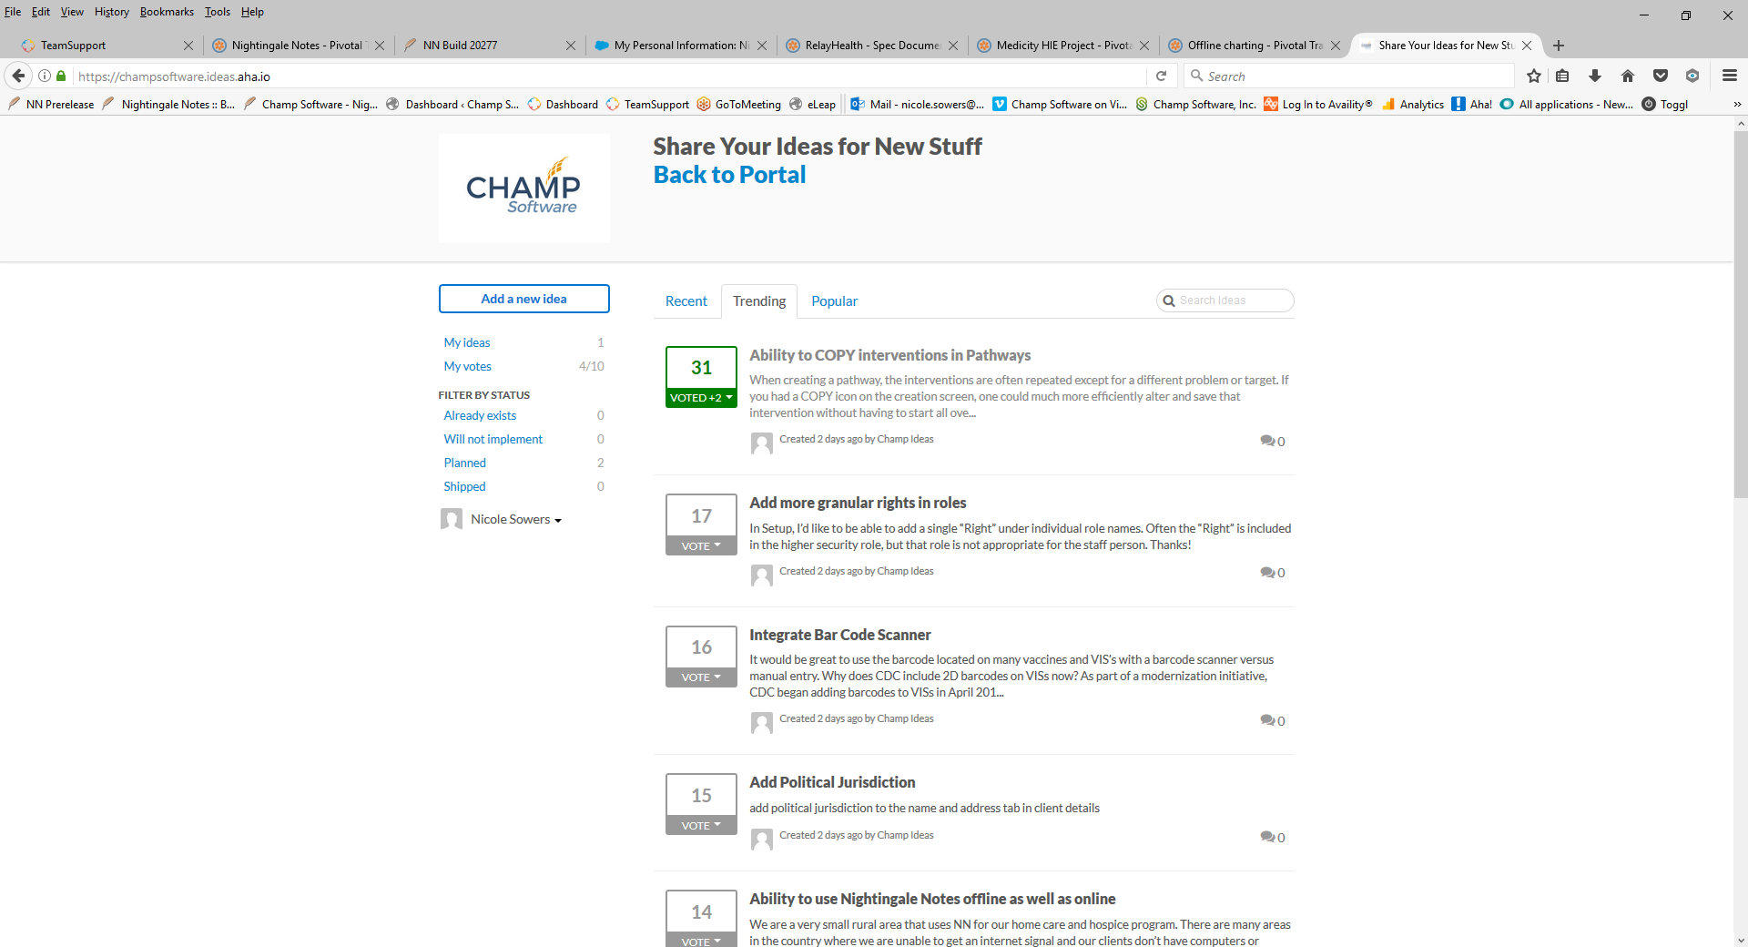
When you enter the Ideas page you will see ideas that are trending, meaning they have the most recent activity and most activity either by votes or comments. Click on the tabs for Recent and Popular to see ideas grouped accordingly.

Searching, voting and commenting:
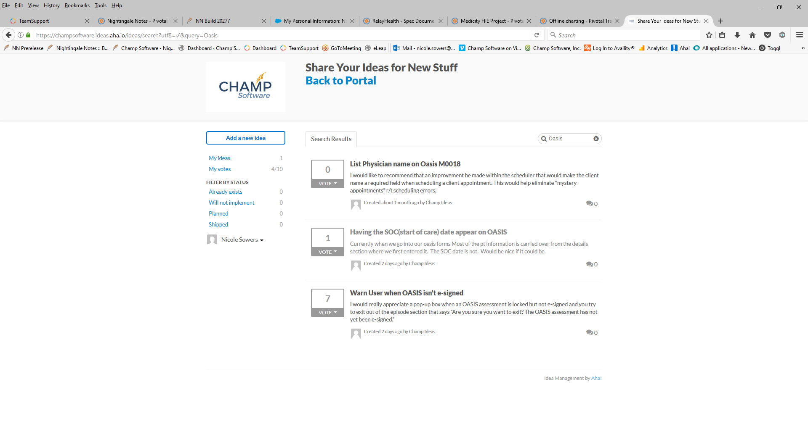
Search for ideas by entering keywords into the Search box. Ideas containing keyword matches are shown and you can then click on those to see more. In the example below the search term Oasis was entered and 3 possible ideas were found.

Cast Votes by clicking the Vote dropdown and selecting the number of votes you want to cast. You can cast all 10 of your votes for a single idea, or spread your 10 votes out across multiple ideas. The dashboard panel on the left side of the screen always shows you the number of votes you have used and the number of votes you are allotted in total. For example, 4/10 indicates you have used 4 of your 10 votes.
Changing your votes can be done by clicking the Vote dropdown and using the negative numbers. This takes your votes away from the idea and puts them back into the pool of total votes you can cast.
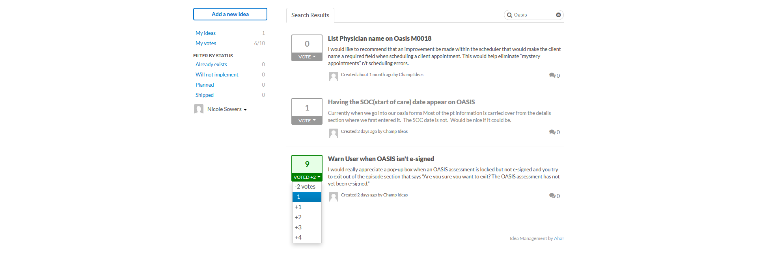
Cast Votes
Add an idea
Ideas in Green are ideas that you’ve cast votes for. Ideas you haven’t voted for are in gray. You can click on an idea to see comments about the idea from others, add your own comments, and know if an idea has made it into the workplan. If a new idea is submitted that you like better than an older idea you voted for, you can remove votes from the old idea and cast them to the new idea. Here are all the possible labels an idea might have and what they mean:
Future Consideration – an idea that hasn’t been evaluated or considered for implementation yet. Still open for voting.
Already Exists – while this is a great idea, it’s already available to use in Nightingale Notes. Support can assist you in finding and using it.
Brought to Gold Task Force – Under Consideration – The idea was a top vote getter and has been submitted to the Gold Task Force for voting. You can still cast votes for this idea while the Gold Task Force is considering it. This evaluation process happens twice a year, in the Spring and Fall.
Planned – The Gold Task Force has chosen this idea and it’s made it into the workplan. No definitive dates are given but if an idea is planned, it will likely be in place in the next 6 – 18 months depending on the complexity of the feature. If you cast votes for an idea and it moves to planned, those votes are automatically put back into your voting pool to be reused for other ideas.
In production – The idea has become a feature in production!
Gold agencies have one agency representative who attends the bi-annual Gold task force meetings. If there are development hours for new feature work remaining after the Gold task force has chosen ideas, from the top vote-getters, to implement, then Champ will look at the next highest vote getters and see if they fit into the left-over allocated hours.

Adding a new idea
If you’ve searched and can’t find your idea, then click Add a new idea.
- Enter a one sentence description, being as specific as possible.
- Add more details in the second text box.
- Choose a category from the category dropdown and Share idea.
- Once saved, you can click on the idea from the idea list and subscribe to get updates when the idea is planned or shipped, or commented on.
Get updates
Let’s move on to submitting and viewing your support tickets. If you’d like to be back at the portal to follow along with the next set of instructions, Click Back to Portal at the top of the Ideas page.

Submitting a Support Ticket:
- Click anywhere on the Support Ticket to enter the Support Portal.

- The first time you visit, you will not see any tickets. We are not able to import and make visible all past tickets you’ve submitted. Once you submit tickets, they will show up in your list of tickets. An example of a list of tickets is shown below.
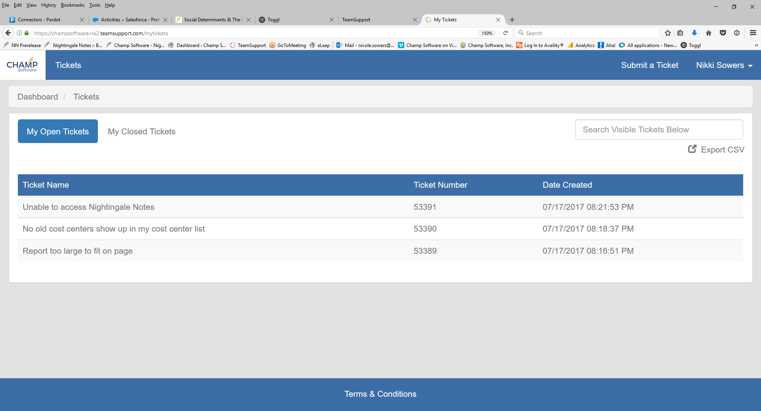
The list shows you open tickets. To see your closed tickets, click on My Closed Tickets.
- Search for tickets. You can search within your existing tickets by using the Search box in the upper right corner.
- Submit a Ticket. You can open a new ticket for an issue or question by clicking the Submit a Ticket button in the upper right corner of the screen.
- View a ticket. You can view the details of your tickets by clicking on them from the list. This will bring up a screen that looks like the one below. In this example, the user clicked on ticket 53389 from their list of open tickets. The most recent ticket updates are available.
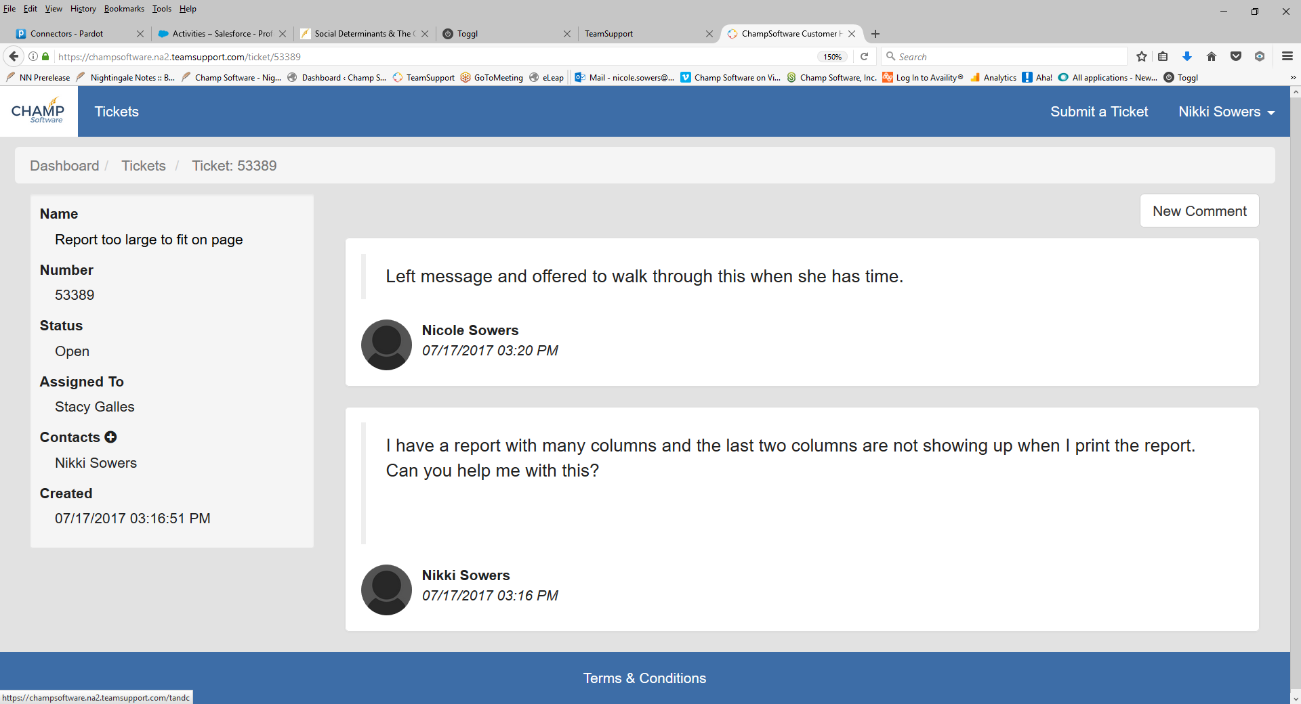
In this ticket the agent tried calling and left a message for you. You can either call Support back at 507-388-4141 or click the New Comment box to add more details When a ticket is updated with new information you will receive an email from Support and the updated comment will also display if you view the ticket in your portal.

Ready to start using the portal?
You can start using the portal as soon as you get these instructions. We recommend you create a bookmark in your browser to access it. Creating a bookmark:
Chrome and FireFox:. Click that star to the right of the URL and the site is added to your list of bookmarked sites.

iPad: Use the box with the up arrow to add a web site to your bookmarks.

You can also access it through the Nightingale Notes Help menu.

That’s It! You are set to use the new Portal. We are excited to see all the great participation from you!

